**I0T Based Home Security System Using Raspberry**

Author i – Asst. Prof. Shweta Shararaswat

Author ii – Abdul Raheem (raheempathan1129@gmail.com)

Author iii – Abhishek Kumar ([23abhishekkumar83@gmail.com](mailto:23abhishekkumar83@gmail.com))

Department Of Computer Science,

Arya Institute of Engineering & Technology, Jaipur.

**ABSTRACT: -**

Nowadays, the intelligent system enabled by the Internet of Things (IOT) has entered a golden era of rapidly growing technology. The Internet of Things is a concept to make every system connected to the Internet. This concept can be used for home security effectively. In this article, we have developed an IoT-enabled system to send a security alert to the home user/owner and registered members via email whenever human intrusion is detected in front of the house door. The IoT Enable home security system consists of a Raspberry Pi-3, a Pi camera, a PIR sensor, a microphone, an ultrasonic sensor, a buzzer, a button bell, an LED/LCD screen and an Internet connection. This item provides two working modes for home security. In the first mode, whenever a person movement is detected and that person presses the doorbell button, the system captures an image and decides the person is familiar or unfamiliar using the database. stored. If the person is unfamiliar, the system will alert the user and registered members via email notification by sending a captured image, video and audio clip of that person. If the person is familiar, the system will capture an image of that person and store it in the system. In the second mode, whenever any suspicious movement of person is detected in front of the door by the system, it will send email notification alert and also activate the security warning alarm system installed at the door. . The designed system provides security against intruders, using the IoT platform.

**INTRODUCTION: -**

Smart devices/systems based on the Internet of Things (IOT) platform have entered a golden age of rapid technological development in the field of home security. IoT is a concept to control and monitor all devices/systems anytime, anywhere, such as internet TVs, smartphones and sensors connected to the internet. Various systems exist for home security purposes, such as microcontroller-based wired and wireless security systems, CCTV systems, etc., but they are very expensive and have limited scope and accessibility to users. In this research work, a cost-effective home security system using PIR sensors based on Raspberry Pi and the design and manufacture of the Pi-Camera. [1,2,10]. In this paper, a home security system based on an IoT platform is developed. Whenever a human intrusion is detected in front of the house, the system sends a security alert to users/homeowners and registered members via email to their smartphones. This email alert will contain an image of the intruder captured by the Pi's camera, as well as video and audio clips of the intruder. A Raspberry Pi-3 is used to program the entire home security system via Python. The system can be installed at the gate of a user's home or office, and the user can then send email alerts to their smartphone from the system from anywhere in the world via the Internet.

**RELATED WORK: -**

In home security systems based on IoT platforms, the focus is on protecting our loved ones and property at home. Today, there are many IoT-based home security systems in the market. According to literature and market research, the common parameters of IoT-enabled home security systems are 24-hour intruder monitoring and detection, real-time, cost-effective and accurate notification systems suggested by various researchers. Below are contributions from various researchers in the field of IoT.

Ran et al. (2018) explained IoT-based home security using the Raspberry Pi, which sends SMS alerts to authorized persons via WAY2SMS and delivers photos of unauthorized persons via email. Dinaka et al. (2018) proposed an IoT-based automated home security system that uses the Raspberry Pi to provide intrusion detection alert and notification to homeowners. Goldeck et al. (2017) in their article explain how an IoT network-based system can send image information to the owner of anyone approaching a home security door. Anwar et al. (2016) explained IoT-based door accessibility and smartphone voice alerts for home security systems. Tanaya and Kishore (2016) explained the use of haar algorithms in open CV to update home security systems with face detection techniques for authorization or construction design and detection.

unauthorized person. Chaudhry et al. (2013) describe an IoT-based remote access control system for authorized personnel at the door using a Raspberry Pi. Internet connection, raspberry pi, pi camera and PIR sensor, these are the common components used in the above system reference. PIR sensors are used for door motion detection and pi cameras are used to capture images based on motion in all systems. Some systems provide remote access to authorized personnel at the door. A lot of work has been done on face and object detection algorithms.

**SYSTEM ARCHITECHTURE DESIGN: -**

Internet of Things (IoT) based home security system with the additional function of detecting and identifying intruders using the YOLO algorithm. The system is implemented on a Raspberry Pi-3 because it can process the captured images with low power consumption and high processing speed. The Raspberry Pi-3 is equipped with all the electronics needed for home security (PIR sensor, ultrasonic sensor, Pi camera, buzzer, speaker and microphone).

In this section, we discuss the architecture of the home security system approach, as shown in Figure 1. In home security architecture, PIR sensor is used to detect the presence of any intruder and it can even work in the dark. Pi cameras are used to capture images of intruders when their presence is detected [3,4,5]. It works in two modes. In the first mode, whenever a person's motion is detected and that person presses the doorbell button, the system captures an image and saves it to a database on a 16GB Micro SD card. The Raspberry Pi processes the images using the YOLO algorithm to detect intruders Python and OpenCV, and then decides if the intruder is familiar with the database. If the person is unfamiliar, an email notification will be sent to users and registered members by sending the person's captured images, video and audio clips as attachments. If the person is familiar, the system will take an image of that person an d store it in the system.

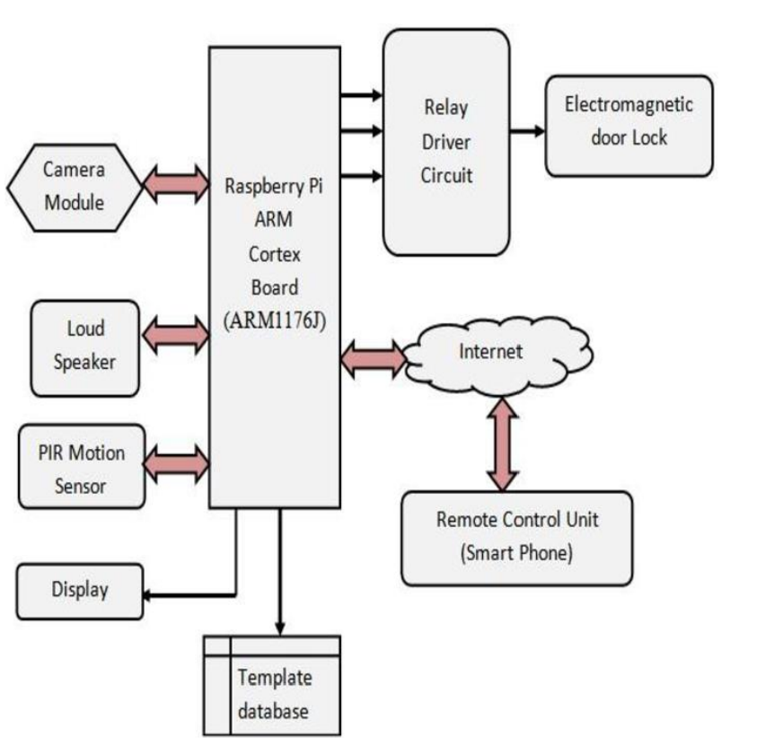

Fig ; 1 – Block Diagram

**SYSTEM COMPONENTS: -**

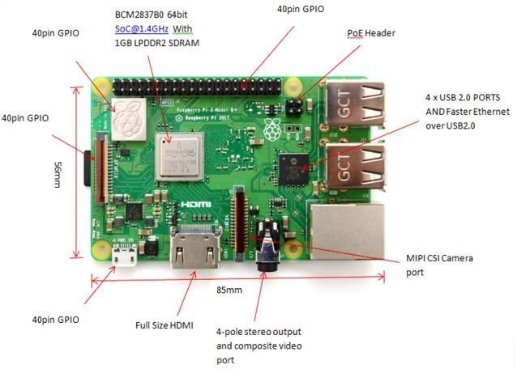

1. Raspberry Pi: -

Raspberry pi The Raspberry Pi is a low cost, credit card sized computer that plugs into a computer monitor or TV, and uses a standard keyboard and mouse. It is a capable little device that enables people of all ages to explore computing, and to learn how to programming languages like Scratch and Python. It's capable of doing everything you'd expect a desktop computer to do, from browsing the internet and playing high-definition video, to making spreadsheets, word-processing, and playing games.

The main features of Raspberry pi-3 as follows: -

* CPU: Quad-core 64-bit ARM Cortex A53 clocked at 1.2 GHz
* GPU: 400MHz Video Core IV multimedia
* Memory: 1GB LPDDR2-900 SDRAM (i.e. 900MHz)
* USB ports: 4
* Video outputs: HDMI, composite video (PAL and NTSC) via 3.5 mm jack
* Network: 10/100Mbps
* Ethernet and 802.11n Wireless LAN

Fig. 2. Raspberry Pi-3 Model B+ Module

* Peripherals: 17 GPIO plus specific functions, and HAT ID bus
* Bluetooth: 4.1
* Power source: 5 V via Micro USB or GPIO header

1. Pi Camera: -

Pi-camera is used to capture the images and videos of any intruder in-front of the home also record it into SD-card. Figure 3 shows Raspberry Pi-Camera module

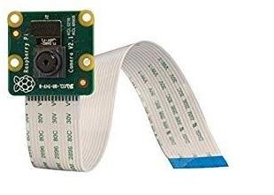

Fig. 3. Pi Camera

The Raspberry Pi Camera Board Features: [1,4]

• Fully Compatible with Both the Model A and Model B Raspberry Pi

• 5MP Omni vision 5647 Camera Module

• Still Picture Resolution: 2592 x 1944

•Video:Supports-1080p @30fps,720p@60fps and 640x480p 60/90 Recording

• 15-pin MIPI Camera Serial Interface - Plugs Directly into the Raspberry Pi Board.

**CONCLUSION AND FUTURE SCOPE: -**

The sensors placed on the door informs the home owner as soon as the door is opened by sending a Push notification. The user will get this notification irrespective of whether the phone is locked or unlocked or even if any other app is opened at the moment. This was the main objective of the project, which is the user feels safe and not worry about any intrusion or break-ins when he is away from home. This setup can also be used in commercial offices where some areas are restricted for certain personnel, such a system will immediately inform the administrator of any unauthorized personnel trying to access such an area. Therefore the

extensibility and applicability of such a system is only limited only by the imagination. Another important component of the project is the connectivity between the ESP8266 (WiFi module) and the Blynk server. The system successfully connected to the Blynk server using the authentication token and the Blynk libraries. As a result, we were able to get the notification on our smart phones as soon as there was any change in the status of the read module sensor. Also the additional ability to control the alarm remotely is very beneficial and can be very useful in some unforeseen circumstances. It was also observed that the Blynk app worked smoothly and carried out all communication between the hardware and the app very accurately.

The developed system can also be used to in industrial and commercial applications such as offices, warehouses and other areas where some areas are reserved for authorized personnel only or other places where safety and precautions are of primary concerns such as internet server room of a hig MNC from where corporate data can be stolen. The system can also be easily upgraded to add extra safety features such as cameras, motion detection sensors, atc. for increased safety. The system can also further be developed by adding an. RFID scanner so that the authorized users need only carry a RFID or NFC tag with them on their person. The RFID scanner will work by scanning the tag wirelessly and if the user is authorized to enter, the alarm system will be disabled for some time so that the user can enter.

**REFRENCES: -**

[1]. R. Rani, S.Lavanya, B.Poojitha, “IoT Based Home Security System Using Raspberry Pi with Email and Voice Alert” International Journals of Advanced Research in Computer Science and Software Engineering ISSN: 2277-128X (Volume-8, Issue-4), April 2018, pp. 119-123.

[2]. Ruby Dinakar, Deepthi U Singh, Mir Mohammed Abbas, Mir Riya Alex, Abhishek Yadav , “IOT Based Home Security System Using Raspberry Pi”, International Journal of Innovative Research in Computer and Communication Engineering, Vol. 6, Issue 4, April 2018, pp. 3835-3842.

[3]. Shreeyash Ghodke, Pushkar Chaudhari, Neha Chumbalkar, Arpit Gupta, Shilpa Lambor, “IOT Based Home Security System Using Raspberry Pi”, Vol. 6, Issue 12, December-2017, pp. 22830-22835.

[4]. Shaik Anwar,D.Kishore., “IOT based Smart Home Security System with Alert and Door” International Journal of Engineering Research & Technology, ISSN: 2278-0181,Vol. 5 Issue 12, December-2016,pp 504-509.

[5]. Tanaya, K.Vadivukarasi, S.Krithiga “HOME SECURITY SYSTEM USING IOT” International Journal of Pure and Applied Mathematics Volume 119 No. 15 2018, pp.1863-1868

[6]. Taryudi, Davin Bagas Adriano, Wahyu Apsari Ciptoning Budi “IoT-based Integrated Home Security and Monitoring System”, IOP Conf. Series: Journal of Physics: Conf. Series 1140 (2018) 012006.

[7]. Madhavarapu Chandan, Sanakkayala Sri Venkat Sumanth , Garapati Samhita , Kathi Priyanka Reddy , “Design & Development of a Home Security System Using IOT”, International Journal of Engineering & Technology, 7 (2.32) (2018) pp.374-376.

[8]. Anitha A, “Home security system using internet of things” , IOP Conf. Series: Materials Science and Engineering 263 (2017) 042026.

[9]. Nasimuzzaman Chowdhury ,Shiblee Nooman, Srijon Sarker “Access Control of Door and Home Security by Raspberry Pi Through Internet” International Journal of Scientific & Engineering Research, Volume 4, Issue 1 November -2013,ISSN 2229-5518 pp.550-558.

[10]. D.S.Kumbhar, H.C. Chaudhari “Development of Wireless Sensor Network for Monitoring and Analysis of Concrete Compressive Strength Development in Early Age Concrete Structure”, International Conference on Functional Materials and Microwaves ICFMM – 2015, December 28-30, 2015.